KODU INSTALLATION

1. | Go to the website:  www.kodugamelab.com
2. | Select (top left of screen)  
3. | Select DOWNLOAD  
4. | Select RUN (bottom of screen)
5. | DOWNLOAD any components not  installed on your computer  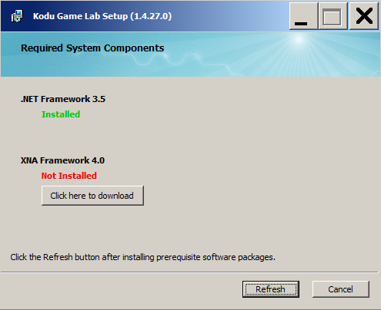 | Note, although this screen may state the the .NET framework is installed, you may find then when you run KODU, it is not installed and you have to install it. This takes some time to install.
6. | Follow a similar process to install additional components. Answer ‘YES’ to questions prompting you to continue. Once computers are installed select REFRESH (the status of the two components should now change to INSTALLED) and then press NEXT

7. | Accept the TERMS and CONDITIONS to install  MICROSOFT KODU GAME LAB 1.4 and select INSTALL  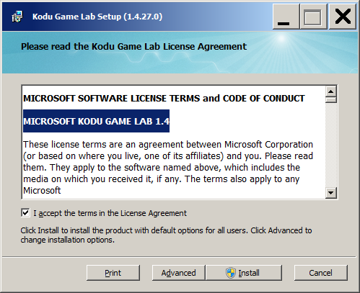
8. | UNCHECK both of the options below.  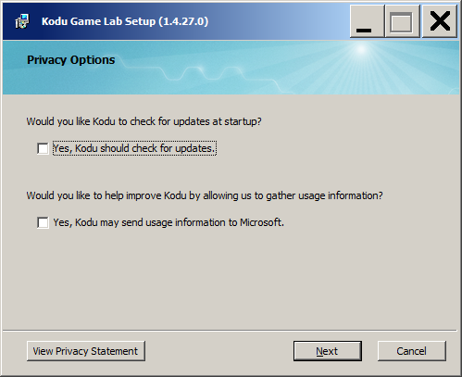  Select NEXT and then YES to allow the program to install.
9. | The installation will take a few minutes to complete.
10. | When complete, select FINISH
11. |  | Once installed the program should appear on your DESKTOP and via the your START menu. On first use, there is a short video to watch before the menu appears. Ignore the message about TOUCH DEVICES and WINDOWS 8.

